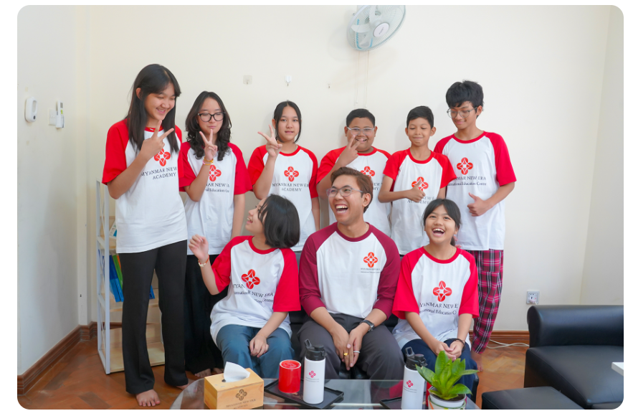 | IGCSE  Our IGCSE programme prepares you for university and beyond with Pearson Edexcel qualifications in Nay Pyi Taw.  Take free placement test
Program Overview: The 2025 intake runs for 15 months from March 2025 toward the May 2026 exam series. Students take a minimum of six subjects (English Language B and Mathematics B, plus electives). Teaching combines theory and practice, with counselling to help you choose subjects that match your interests and future pathway.
Who Should Join: Students who are ready for international secondary qualifications and want core English and Mathematics alongside sciences, business, economics, accounting, ICT, or further mathematics.

Subjects:  Core Subjects  - English Language B  - Mathematics B | Optional Subjects  - Chemistry  - Physics  - Biology  - Business Studies  - Economics  - Accounting  - ICT  - Computer Science  - Further Pure Mathematics
Program Details
Duration:15 Months2025 intake · May 2026 exam series
Time:9:00 am – 4:30 pm
Starting Date:March 2025
IGCSE Exam:May 2026 Series
Exam Board:Pearson Edexcel
Minimum Subjects:6 subjects (2 core + electives)
Registration Fees:K 400,000
School Fees:K 740,000 per month(6 subjects)
Key Benefits of Program
- Globally Recognized Qualification
- Experienced & Inspiring Teachers
- Ideal Space for Learning & Growth
- Exam preparation (Pearson Edexcel)
- Counselling for subject and career pathways
Take free placement test

